Small Office VLAN Network with Inter-VLAN Routing, DHCP, and Security Controls
By: Cue Patrick Khan
Tool: Cisco Packet Tracer
Domain: Network design, switching, routing, network security
Skills demonstrated: VLAN segmentation, 802.1Q trunking, router-on-a-stick inter-VLAN routing, centralized DHCP, port security, ACLs, STP troubleshooting

Table of Contents
1. Overview 1
2. Network Design 2
3. Implementation 2
Step 1- Topology construction 2
Step 2- Device naming 3
Step 3- VLAN creation 3
Step 4- Trunk port configuration 3
Step 5- Access port configuration 4
Step 6- Router subinterface configuration 4
Step 7- DHCP configuration 5
VLAN segmentation and trunking 5
Inter-VLAN routing (router-on-a-stick) 5
Centralized DHCP 5
4. Troubleshooting Highlights 8
5. Validation 9
6. What This Project Demonstrates 9

1. Overview
I designed and configured a segmented small-office network simulating a company with three departments, each isolated on its own VLAN while sharing a single routed gateway. The project covers the full life cycle of a layer 2/3 deployment: physical topology, VLAN design, trunking, inter-VLAN routing, automated address assignment, and a layer of security hardening.
It maps directly to core CCNA exam objectives and reflects the kind of design and troubleshooting work a network administrator or engineer handles.

2. Network Design
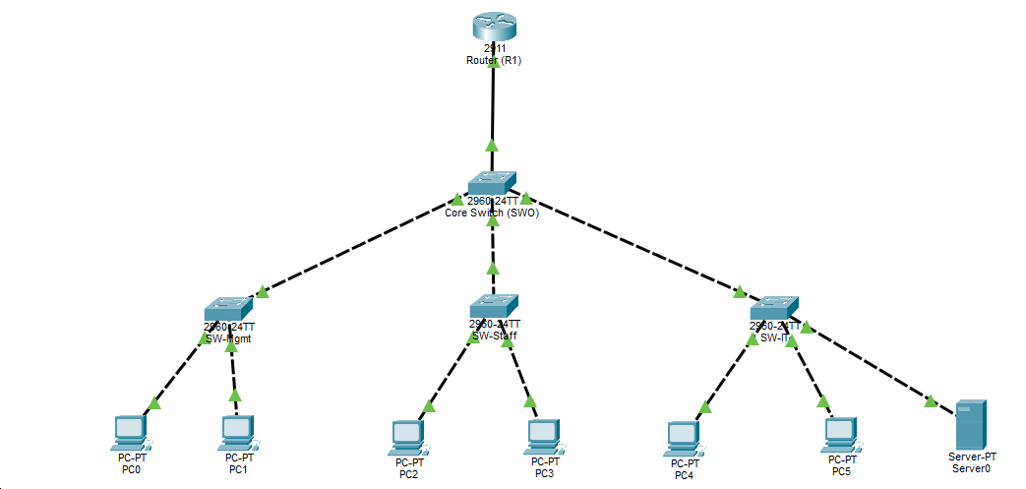

The topology uses a collapsed-core layout: one router providing routing and DHCP services, one core switch aggregating the access layer, and three access switches each serving a department. Each VLAN gateway is a subinterface on the router, allowing a single physical link to route traffic between all three VLANs (router-on-a-stick).

Department | VLAN | Subnet | Gateway | Access switch
Management | 10 | 192.168.10.0/24 | 192.168.10.1 | SW-Mgmt
Staff | 20 | 192.168.20.0/24 | 192.168.20.1 | SW-Staff
IT | 30 | 192.168.30.0/24 | 192.168.30.1 | SW-IT

3. Implementation

Step 1- Topology construction
The network was built inside Cisco Packet Tracer using the following devices:
1 x Cisco 2911 router (R1) - handling inter-VLAN routing and DHCP
1 x Cisco 2960-24TT switch (SW0) - acting as the core/aggregation switch
3 x Cisco 2960-24TT switches (SW-Mgmt, SW-Staff, SW-IT) - acting as department-level access switches
6 x PCs (PC0-PC5) - two per department
1 x Server (Server0) - placed on the IT department switch

Devices were placed on the canvas and labelled by configuring the hostname on each device via the CLI. The physical connections were made as follows:
R1 GigabitEthernet0/0 -> SW0 FastEthernet0/1 using a copper straight-through cable
SW0 FastEthernet0/2 -> SW-Mgmt FastEthernet0/1 using a copper crossover cable
SW0 FastEthernet0/3 -> SW-Staff FastEthernet0/1 using a copper crossover cable
SW0 FastEthernet0/4 -> SW-IT FastEthernet0/1 using a copper crossover cable
Each access switch connected its PC-facing ports (Fa0/2, Fa0/3) to end devices using copper straight-through cables
SW-IT additionally connected Fa0/4 to Server0
Straight-through cables were used between unlike devices (router to switch, switch to PC) and crossover cables between like devices (switch to switch).

Step 2- Device naming
Each device was given a hostname via the CLI to keep the environment organised and match the topology diagram. On each device:
Switch> enable
Switch# configure terminal
Switch(config)# hostname SW0
This was repeated on all four switches and the router, substituting the appropriate name each time.

Step 3- VLAN creation
Three VLANs were created on every switch in the topology. VLANs must exist on a switch before that switch can carry or assign traffic to them, so this step was completed on SW0 and all three access switches.
SW0(config)# vlan 10
SW0(config-vlan)# name Management
SW0(config-vlan)# exit
SW0(config)# vlan 20
SW0(config-vlan)# name Staff
SW0(config-vlan)# exit
SW0(config)# vlan 30
SW0(config-vlan)# name IT
SW0(config-vlan)# exit
Completion was verified using show vlan brief, which confirmed all three VLANs were active on each switch.

Step 4- Trunk port configuration
Trunk ports carry traffic for multiple VLANs simultaneously across a single link using 802.1Q tagging. All uplink ports (the port on SW0 facing R1, the ports on SW0 facing each access switch, and the uplink port on each access switch facing SW0) were configured as trunks.
On SW0:
SW0(config)# interface FastEthernet0/1
SW0(config-if)# switchport mode trunk
SW0(config)# interface FastEthernet0/2
SW0(config-if)# switchport mode trunk
SW0(config)# interface FastEthernet0/3
SW0(config-if)# switchport mode trunk
SW0(config)# interface FastEthernet0/4
SW0(config-if)# switchport mode trunk
The same was applied to the Fa0/1 uplink on each access switch. Trunk configuration was verified using show interfaces trunk, which confirmed 802.1Q encapsulation and all three VLANs active and forwarding on each trunk link.

Step 5- Access port configuration
Ports facing end devices on each access switch were configured as access ports and statically assigned to the appropriate VLAN. An access port carries traffic for only one VLAN and does not tag frames — the connected device is unaware of the VLAN it belongs to.
On SW-Mgmt:
SW-Mgmt(config)# interface FastEthernet0/2
SW-Mgmt(config-if)# switchport mode access
SW-Mgmt(config-if)# switchport access vlan 10
SW-Mgmt(config)# interface FastEthernet0/3
SW-Mgmt(config-if)# switchport mode access
SW-Mgmt(config-if)# switchport access vlan 10
This was repeated on SW-Staff with VLAN 20 and SW-IT with VLAN 30. The show vlan brief command was used to confirm each port appeared under the correct VLAN.

Step 6- Router subinterface configuration
With all switches configured, inter-VLAN routing was enabled on R1 using the router-on-a-stick method. A single physical interface (GigabitEthernet0/0) was brought up without an IP address, and three logical subinterfaces were created — one per VLAN — each configured with dot1Q encapsulation and the gateway IP for its subnet.
R1(config)# interface GigabitEthernet0/0
R1(config-if)# no shutdown

R1(config)# interface GigabitEthernet0/0.10
R1(config-subif)# encapsulation dot1Q 10
R1(config-subif)# ip address 192.168.10.1 255.255.255.0

R1(config)# interface GigabitEthernet0/0.20
R1(config-subif)# encapsulation dot1Q 20
R1(config-subif)# ip address 192.168.20.1 255.255.255.0

R1(config)# interface GigabitEthernet0/0.30
R1(config-subif)# encapsulation dot1Q 30
R1(config-subif)# ip address 192.168.30.1 255.255.255.0
The no shutdown on the parent interface is critical, so they will remain down even if individually configured unless the physical interface is explicitly brought up.

Step 7- DHCP configuration
DHCP pools were configured on R1 to automate IP address assignment for all three VLANs. The first ten addresses in each subnet were excluded to reserve them for network infrastructure such as switch management interfaces and the router itself.
R1(config)# ip dhcp excluded-address 192.168.10.1 192.168.10.10
R1(config)# ip dhcp excluded-address 192.168.20.1 192.168.20.10
R1(config)# ip dhcp excluded-address 192.168.30.1 192.168.30.10

R1(config)# ip dhcp pool MGMT
R1(dhcp-config)# network 192.168.10.0 255.255.255.0
R1(dhcp-config)# default-router 192.168.10.1
R1(dhcp-config)# dns-server 8.8.8.8

R1(config)# ip dhcp pool STAFF
R1(dhcp-config)# network 192.168.20.0 255.255.255.0
R1(dhcp-config)# default-router 192.168.20.1
R1(dhcp-config)# dns-server 8.8.8.8

R1(config)# ip dhcp pool IT
R1(dhcp-config)# network 192.168.30.0 255.255.255.0
R1(dhcp-config)# default-router 192.168.30.1
R1(dhcp-config)# dns-server 8.8.8.8
Each PC was set to DHCP via Desktop > IP Configuration. Successful address assignment was verified using ipconfig on each PC and show ip dhcp binding on R1, which listed every leased address alongside its corresponding MAC address and pool.

VLAN segmentation and trunking
Each VLAN was created on every switch and propagated across 802.1Q trunk links between the core and access switches. Access ports facing end devices were statically assigned to their department VLAN, while uplinks were configured as trunks to carry all VLAN traffic.
SW0(config)# interface FastEthernet0/3
SW0(config-if)# switchport mode trunk

Inter-VLAN routing (router-on-a-stick)
A single router interface was divided into three subinterfaces, each tagged with its VLAN ID and assigned the gateway address for that subnet.
R1(config)# interface GigabitEthernet0/0.20
R1(config-subif)# encapsulation dot1Q 20
R1(config-subif)# ip address 192.168.20.1 255.255.255.0

Centralized DHCP
The router was configured with three DHCP pools, one per VLAN, with the first ten addresses in each subnet excluded and reserved for infrastructure. Clients across all departments receive addressing automatically.
R1(config)# ip dhcp pool STAFF
R1(dhcp-config)# network 192.168.20.0 255.255.255.0
R1(dhcp-config)# default-router 192.168.20.1
Security Hardening
Three controls were layered on top of the working network:
- Port security restricts each access port to a single learned MAC address, shutting the port down on a violation to prevent unauthorized devices.

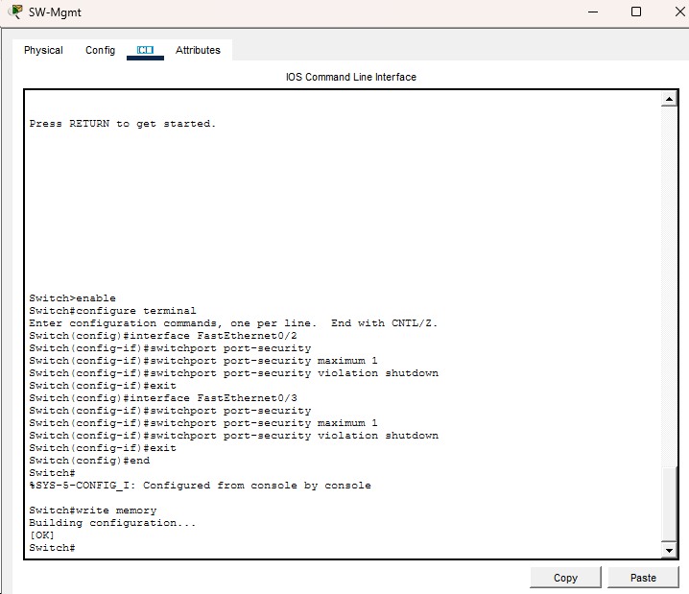
- Unused ports disabled across all access switches to reduce the attack surface.
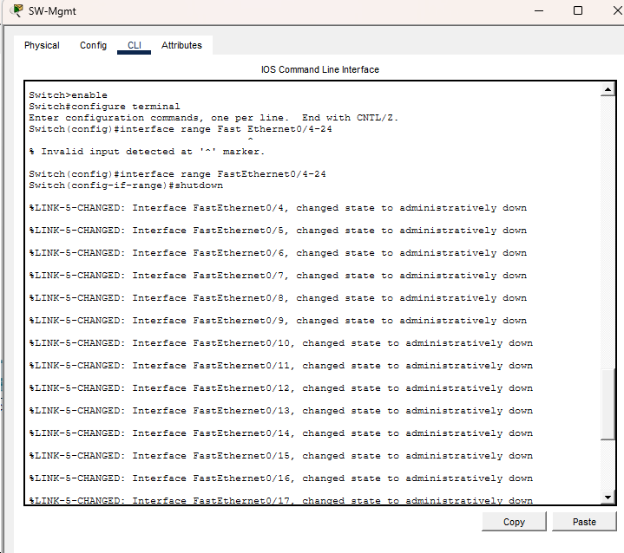
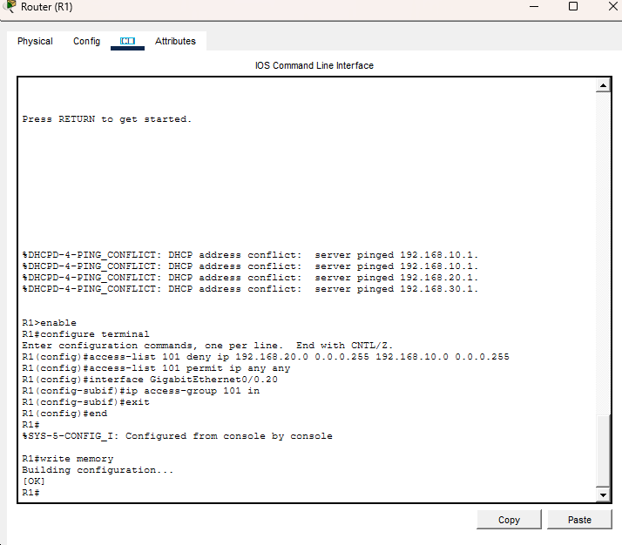
- Access control list (ACL) on the Staff VLAN subinterface blocks Staff from reaching the Management subnet while permitting all other inter-VLAN traffic.

4. Troubleshooting Highlights
The build surfaced several realistic faults that were diagnosed and resolved:
- DHCP clients failing to obtain addresses traced through a chain of causes: a router physical interface left administratively down, trunk links that had renegotiated to default after re-cabling, and spanning-tree blocking on freshly connected ports.
- Cabling mismatch between the router and core switch (straight-through versus crossover), diagnosed by verifying port assignments and link state.
- STP convergence delays resolved by setting the core switch as the root bridge and configuring the access switches as secondary, then enabling PortFast on edge ports.
Verification was done throughout using show vlan brief, show interfaces trunk, show ip dhcp binding, and show spanning-tree, with end-to-end testing via ICMP across VLANs.

5. Validation
The completed network was verified against the intended design:
- DHCP: All clients receive correct addressing within their VLAN subnet.
- Routing: Inter-VLAN routing succession between all permitted department pairs.
- Security policy: Staff-to-Management traffic is correctly denied while Staff-to-IT routing remains functional, confirming the ACL enforces as designed.

6. What This Project Demonstrates
This build shows end-to-end competence across the access and distribution layers; designing an addressing scheme, segmenting a network with VLANs, enabling routing between them, automating host configuration, and enforcing a security policy, along with the structured troubleshooting needed to bring a network from broken to fully operational.

